John Maher

Chapter 7

Pg 254

SELECT * INTO sec0703_employees_copy FROM sec0703_employees;

INSERT INTO sec0703_employees_copy VALUES(211, 'John', 'Maher', 'IT', #FEB 20 2020 10:00 AM#, 50, 3278, null);

SELECT * FROM sec0703_employees_copy;

| **Query3** | | | | | | | |
| --- | --- | --- | --- | --- | --- | --- | --- |
| **EMPLOYEE_ID** | **FIRST_NAME** | **LAST_NAME** | **DEPT_CODE** | **HIRE_DATE** | **CREDIT_LIMIT** | **PHONE_NUMBER** | **MANAGER_ID** |
| 201 | Susan | Brown | Exe | 6/1/1998 | $30.00 | 3484 |  |
| 202 | Jim | Kern | Sal | 8/16/1999 | $25.00 | 8722 | 201 |
| 203 | Martha | Woods | Shp | 2/2/2009 | $25.00 | 7591 | 201 |
| 204 | Ellen | Owens | Sal | 7/1/2008 | $15.00 | 6830 | 202 |
| 205 | Henry | Perkins | Sal | 3/1/2006 | $25.00 | 5286 | 202 |
| 206 | Carol | Rose | Act |  |  |  |  |
| 207 | Dan | Smith | Shp | 12/1/2008 | $25.00 | 2259 | 203 |
| 208 | Fred | Campbell | Shp | 4/1/2008 | $25.00 | 1752 | 203 |
| 209 | Paula | Jacobs | Mkt | 3/17/1999 | $15.00 | 3357 | 201 |
| 210 | Nancy | Hoffman | Sal | 2/16/2007 | $25.00 | 2974 | 203 |
| 211 | John | Maher | IT | 2/20/2020 10:00:00 AM | $50.00 | 3278 |  |

Pg 262

ALTER TABLE sec0708_departments ADD COLUMN row_id counter;

SELECT * FROM sec0708_departments;

| **Query3** | | |
| --- | --- | --- |
| **DEPT_CODE** | **DEPARTMENT_NAME** | **row_id** |
| Act | Accounting | 1 |
| Exe | Executive | 2 |
| Mkt | Marketing | 3 |
| Per | Personnel | 4 |
| Sal | Sales | 5 |
| Shp | Shipping | 6 |

Pg 264

CREATE INDEX ix_sec0709_departments ON sec0709_departments (department_name);

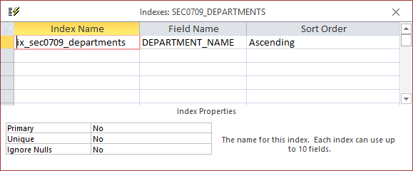

Pg 269

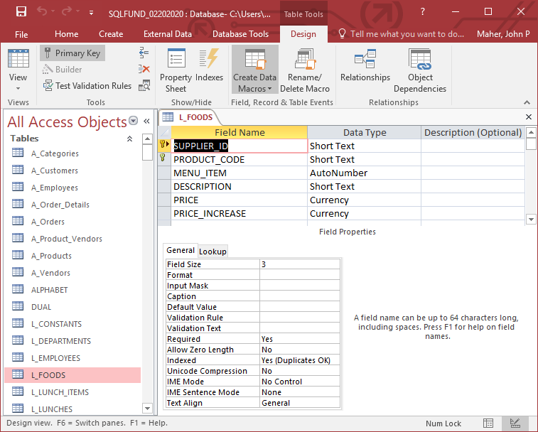

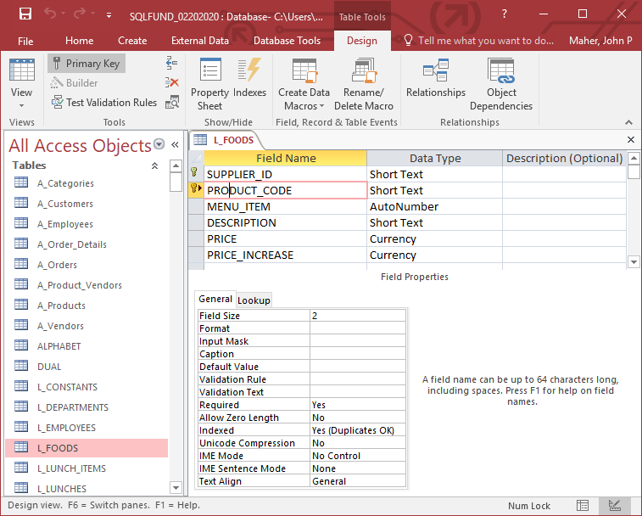

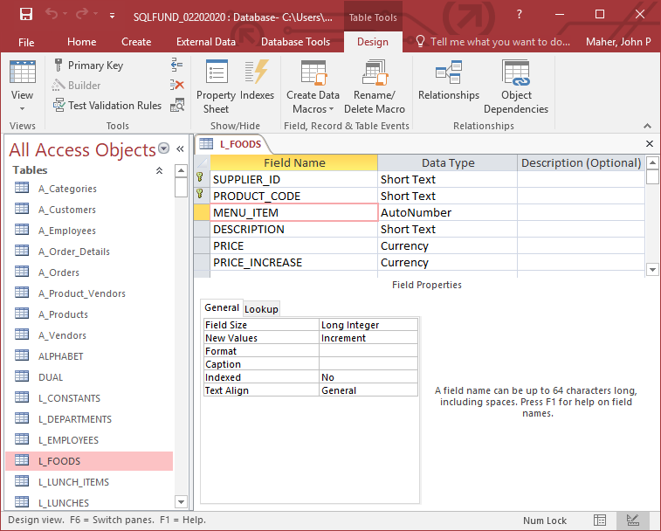

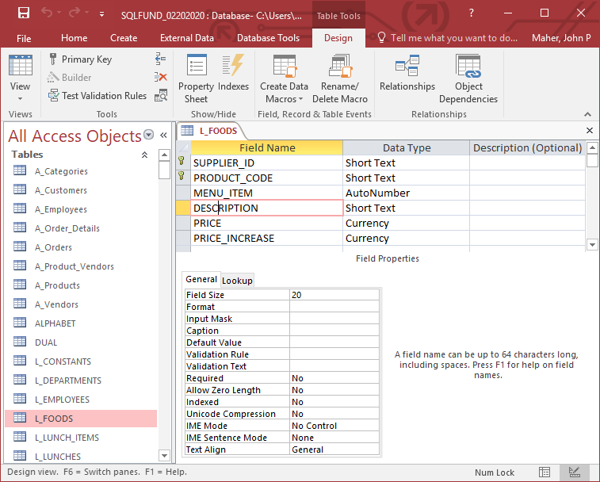

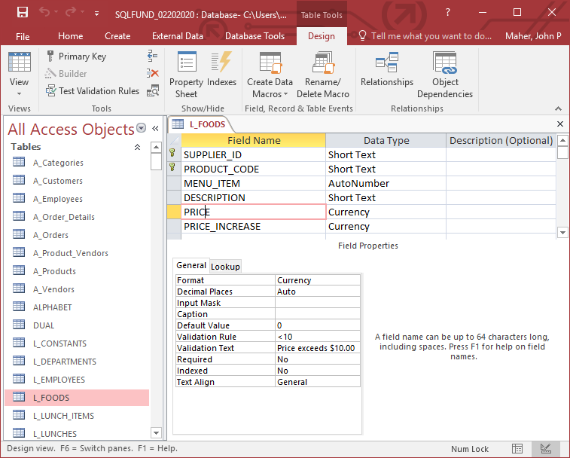

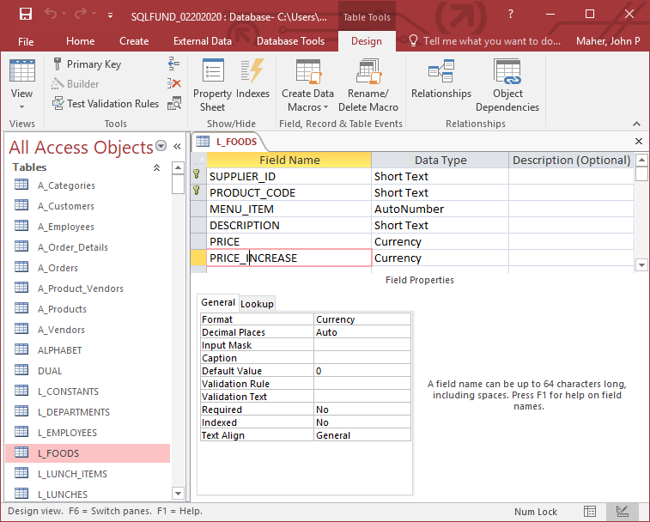

Pg 274

